1. Explain SDLC at a high level: The software development cycle is a concept that describes the phases of software development. It’s cyclical to allow for flexibility (or agility) when it comes to making modifications. SDLC splits up the project into few week periods known as sprints.  
    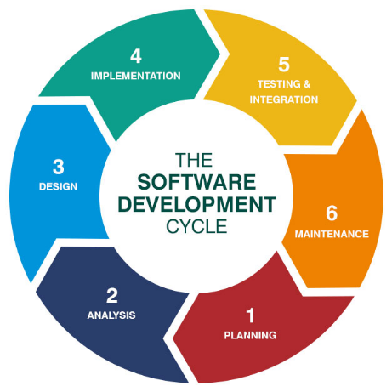
2. What is waterfall and why it is still relevant? The waterfall development method is a process that describes the development stages of a piece of software. It flows from stage to stage in a linear way as such: Requirements 🡪 design 🡪 implementation 🡪 verification 🡪 Maintenance. There are many cons to using waterfall. You’re required to get everything right the first time because there is no feedback loop which makes it difficult and clunky to alter something in the design stage once you’ve already proceeded to the implementation stage. In my opinion it is still relevant because it’s more straightforward than any other method. It’s simplicity is useful if you’re developing non-complex application. It feels more natural and it’s the development approach you would take if you didn’t know any better.
3. Explain Agile Model with a use case and the role of SCRUM in that: Unsure what is meant by “model”, is it referring to a model of the development cycle or to agile modelling?
4. Who is Scrum Master? A Scrum Master the person responsible to make sure a scrum project is running smoothly. Any SCRUM related issues are dealt with by the Scrum Master so the team can focus on the project.
5. Differentiate between Product/Sprint Backlog: A product backlog describe what must be done to complete the entire project whilst a sprint backlog describes only a subset of that.
6. What is Epic & Story: An epic is a general use case which consists of individual features. A story represents such a feature.
7. What is called Velocity in SCRUM? Velocity is the rate at which teams can complete a project.
8. Explain the SCRUM ceremonies: Ceremonies are a category of Scrum practices. They are specific meetings that are part of the Scrum framework and help boost productivity and team cohesion.
9. What is grooming? It’s a review of the backlog to make sure it’s up to date and that things are prioritised correctly.
10. How Jira board is effective in SCRUM: makes it easy to track and schedule tasks and to monitor progress.
11. Differentiate between SCRUM & Waterfall: Waterfall is a linear and process-oriented approach whilst scrum follows and iterative and team-based approach.
12. Explain the responsibilities of Product Owner: The product owner must have a clear vision of the goal product that is being worked towards. The owner must clearly express and order the product backlog items and make clear to all what the Scrum Team will work on next ensuring they understand the items in the product backlog.